Logo%20Main%20200

**Boston University**

**Electrical & Computer Engineering**

**EC464 Capstone Senior Design Project**

User's Manual



*Submitted to:*

Professor Alan Pisano

Boston University

(617) 353 6264

apisano@bu.edu

*by*

Team 22

Running Safety

*Team Members:*

Thomas Cimino tpcimino@bu.edu

Zexing Gao zexing@bu.edu

Cong Han hancong@bu.edu

Payton Hauck phauck@bu.edu

Yajing Lai cassielo@bu.edu

*Submitted: April 5, 2019*

#### Running Safety Plus

#### Table of Contents

Executive Summary 1

1 Introduction 2

2 System Overview and Installation 3

2.1 Overview block diagram 3

2.2 User interface. 3

2.3 Physical description. 6

2.4 Installation, setup, and support 7

3 Operation of the Project 8

3.1 Operating Mode 1: Normal Operation 8

3.2 Operating Mode 2: Abnormal Operations 8

3.3 Safety Issues 9

4 Technical Background 10

5 Cost Breakdown 13

6 Appendices 14

6.1 Appendix A - Specifications 14

6.2 Appendix B – Team Information 15

(Right click on Table of Contents to update fields and page numbers automatically)

# Executive Summary

Running Safety Plus is a safety device used by runners, joggers, and walkers of all ages that will be useful for emergency situations of any type. Comfortably concealed and durable enough to fulfill all of its functions, our device will track GPS coordinates, heart rate, the running force, and contact an emergency contact when needed. Our device consists of both a shoe insert and chest strap to help avoid false positives and provide a more accurate detection of emergencies. Using a GPS, sim card, and bluetooth functionalities, the device is programmed through a web application which is where preferences are set and data is stored.

# Introduction

In the United States over 64 million people responded that they jog or run regularly in their free time as a source of exercise. Specifically in the state of Massachusetts, running is seen as the most common form of exercise for people of all ages. This common form of exercise is usually completed alone and, depending on the environment surrounding that runner, could be dangerous. As our customer explained, there has been a rise in the amount of reported abduction or sexual assault attempts to young women while jogging alone. Health emergencies are other common dangerous situations that can occur to runners if they are out on their own, leaving them stranded with no one around to help them in some cases. Our team, with the help from our customer, plans on solving this problem by designing a functional device that can help runners of all ages be more safe during their exercising routines. Our customer helped plan the product design which consists of two parts including a shoe insert and a wearable chest strap. This design reassures that the products will be concealed and therefore not easily seen by the public eye, which can be very important in certain emergency situations.

In order to design a strong and efficient device, our team approached our design by focusing on three main measurements to determine if an emergency is taking place. First, measuring one’s heart rate for abnormal spikes is an easy way to determine if the runner is undergoing some type of stress. Heart rate spikes can be caused by a rush of adrenaline which usually occurs when one is in a dangerous or emergency situation. Our other approach to detecting an emergency is through the use of a force sensor that will be part of the shoe insert. This will signal whether or not the user is actually running. Obviously, if the user is not running there will be no force reading and if they do not cancel the alert then there's some type of situation that needs help. Finally our last 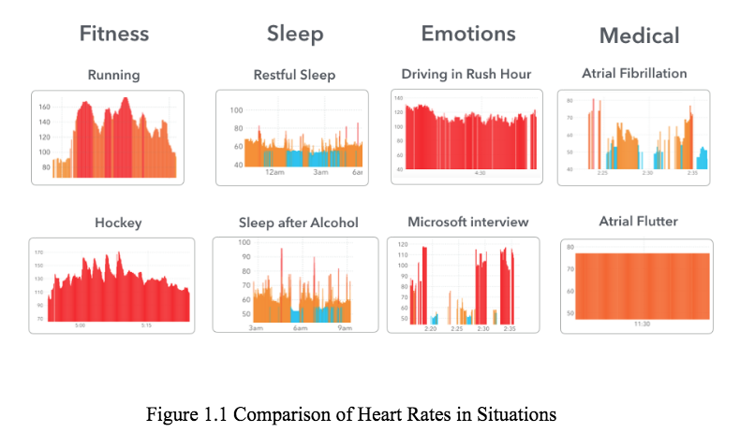

approach involved tracking the user’s GPS location and this is helpful in many ways in that if there was an emergency, we have the location of the runner. GPS location is very common and can easily be integrated into many devices these days and our group took advantage of this.

Throughout the remainder of this manual, user’s will understand the System Overview and how to operate the Running Safety Plus device. The appendices also offer extra information in case the user is confused in any way. Let’s go run safe!

# System Overview and Installation

## Overview block diagram

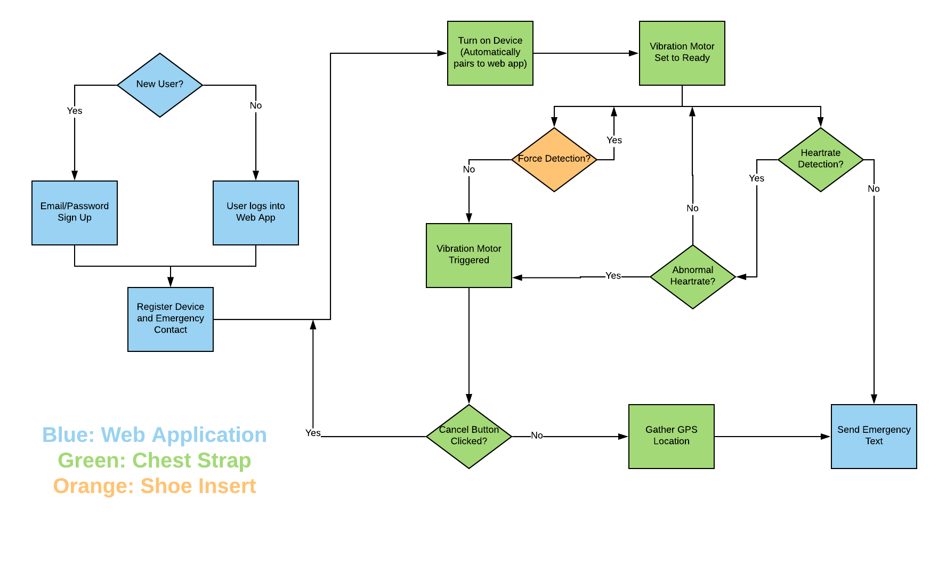

## User interface.

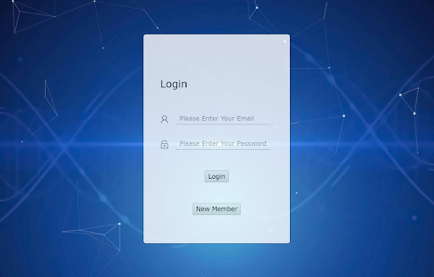

**Login Page:** This is where users are able to enter their personal data if they already have an account with the system. Users can click new member if not.

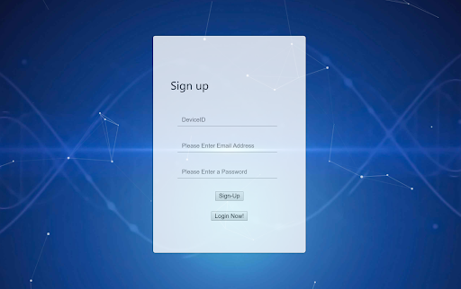

**Sign-Up Page:** If the user clicked on New Member, this is where they will be directed to enter the information they want stored. The device ID is optional at this point as there is a later step to submit also.

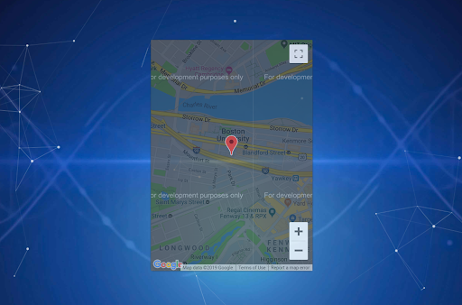

**Home Page:** This is displaying the map feature that can be viewed once a member signs in to their account. It will show the last location of the device.

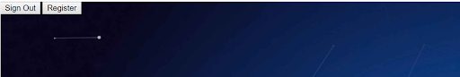

**Registration/Sign Out:** These two buttons are automatically displayed on the home screen for when a user wants to register or sign out. The register button will lead the user to inputs in order to enter the contact and deviceID.

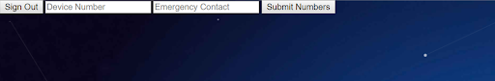

**Submission:** After clicking the register button the user will be able to enter the data and send it directly to the database. The linkage between the deviceID and emergency contact will be how our system knows what emergency contact to send a SMS during an emergency.

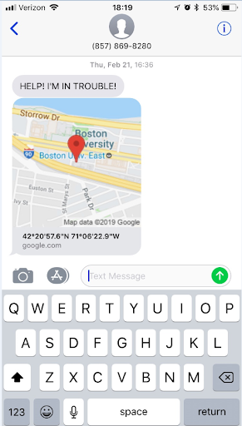

**Emergency Text:** This is an example of the emergency text that will be sent to the emergency contact programmed into the database. The map link is clickable so that the emergency contact can see the exact location.

## Physical description.

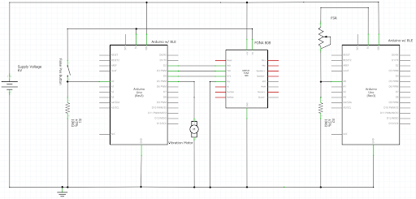

**Hardware Diagram:** This diagram helps lay out the hardware modules that are included in our device. Outlining the two BLE Arduinos with the force resistor and FONA GPS system.

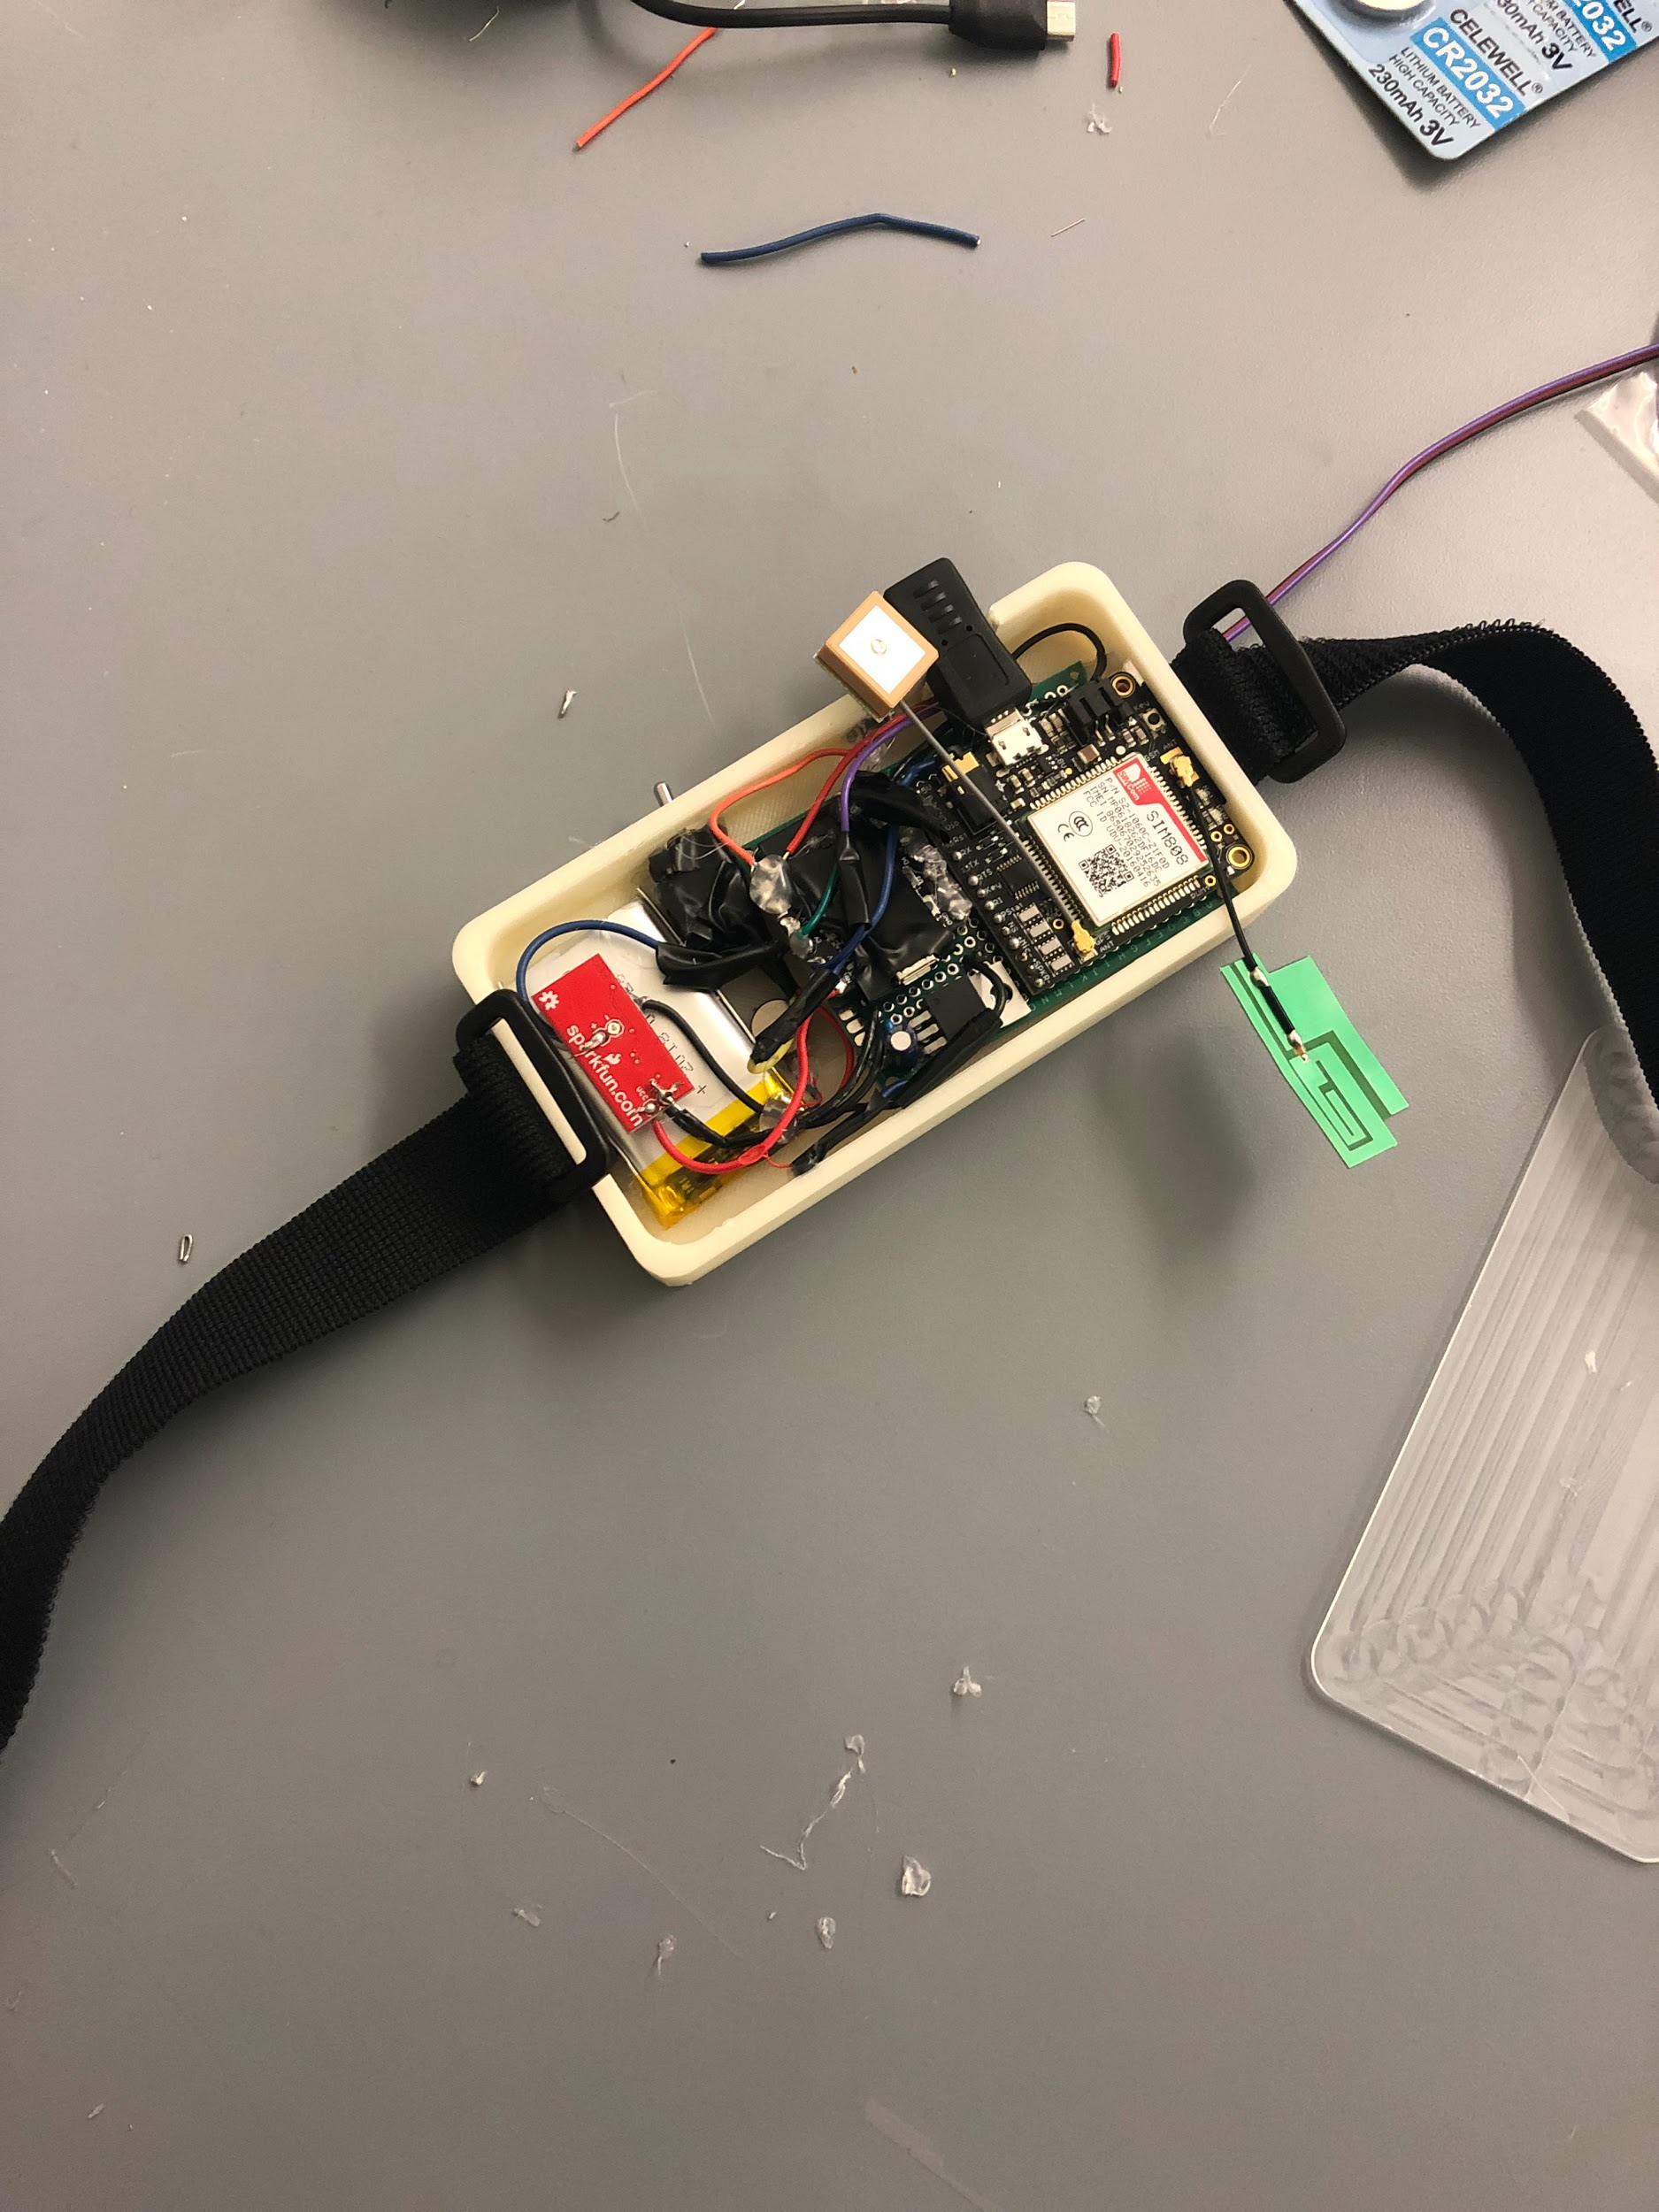

**Chest Strap:** This is the enclosing that stores majority of the modules and the user will wear wrapped around the chest. Not pictured is the pulse monitor that runs along the strap so that it directly touches the user’s skin.

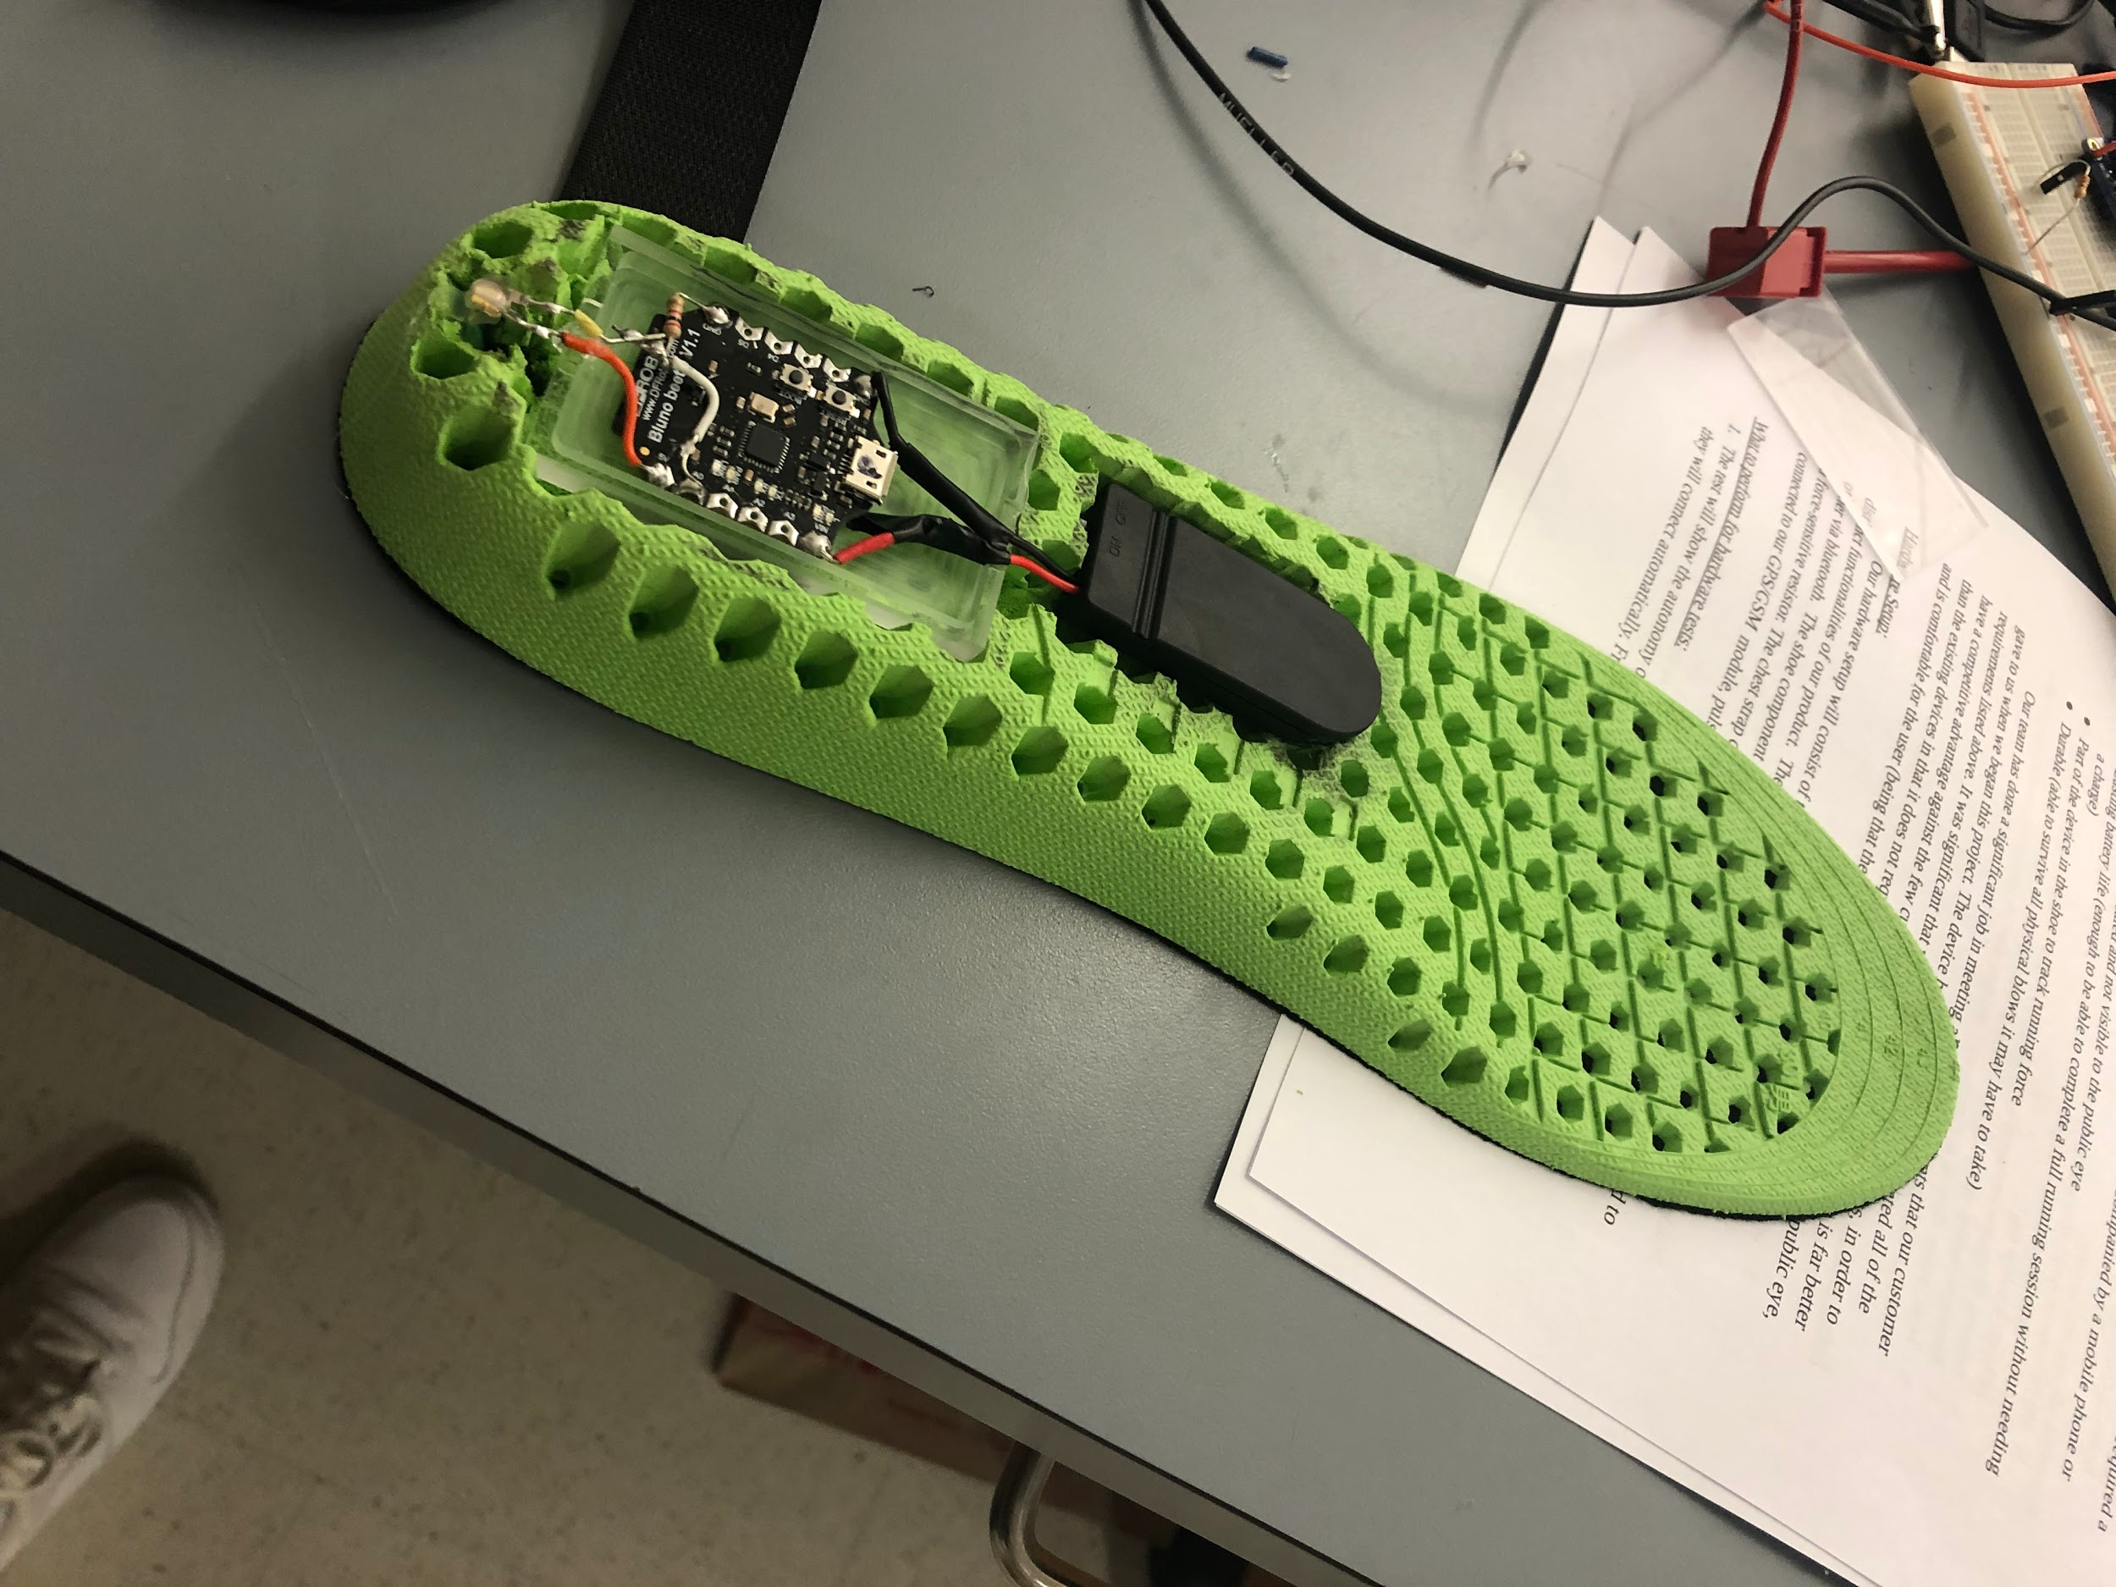

**Shoe Insert:** The shoe insert includes battery, bluetooth, and the force sensor (unshown - placed under the heel area). This will be inserted directly into the user’s shoe to track whether they are running or not.

## Installation, setup, and support

*Software:*

Accessing the web application should be easy for all users. Due to the implementation of hosting on AWS, all users can just access the web app through the link: [www.seniordesignrunningsafety.com:8080/login.html](http://www.seniordesignrunningsafety.com:8080/login.html). By hosting on AWS, this avoids having users go through any installations or package downloads.

*Hardware:*

All hardware pairs automatically when the devices are both turned on individually. Shoe insert will be inserted directly into sneaker and should fit well. (Allowed to trim front of insert. May take ~20 seconds for them to pair.) Watching the pattern of the blinking blue LED in the chest strap housing is how you can tell what state the modules are in:

* 64ms on, 800ms off: Device is on and initializing connections.
* 64ms on, 3 seconds off: Device is acquiring connections.
* 64ms on, 300ms off: Device is fully initialized.

# Operation of the Project

## Operating Mode 1: Normal Operation

Shoe Device and Chest/Back Strap:

Simply turn both devices on and they will automatically pair and initialize themselves. The shoe on/off switch is located on the flat end of the black battery pack on the underside of the shoe insert. The chest/back on/off switch is the toggle switch on the side of the device housing. Turn these devices on and wait for a 2-second vibration from the chest/back housing. This pulse means the devices are all initialized and ready to operate. Keep in mind that at this point the shoe device is actively monitoring pressure on the insert and will send a warning signal if it does not detect any pressure within 10 seconds. Place the insert into your shoe and put your shoe on as quickly as possible. Place the chest/back device in a comfortable position on your torso (we’ve found the center of the back seems to work well). Wrap the elastic velcro straps around your torso and join them together, with the pulse monitor placed firmly against your skin. For this, we’ve found the best placement seems to be at the base of the sternum where both sides of your rib cage join together.

During your run, both subsystems are monitoring different signals to try to detect if you may be in some sort of distress situation. This device is completely autonomous and accomplishes this task without any user input. However, if there is a false positive detection while you are in a safe environment and the chest/back device begins to vibrate, simply press the button next to the on/off switch to set the device back to normal operation mode. You will have 10 seconds to press this button from the time the device begins to vibrate before the device sends the emergency text message.

Web application

After you opened the website, you have to click sign-up button if it is your first time use this system. You will need your Device ID and your email address in order to finish the sign up process. After you fill up all blanks, you click login new button, the system would bring you in. Once you get into the system, remember to provide your ideal emergency contact by clicking register button. After you input the Device ID and emergency contact, you have to click submit button to finish this process. You would see an alert if you make it. If you feel that you are no longer need this page, you can click sign out button to log yourself out from the system.

## Operating Mode 2: Abnormal Operations

Chest/Back Device Charging:

The toggle switch **MUST** be in the off position to avoid sending any unintended emergency texts. After that, simply plug in any microUSB cable into the charging port and the battery will charge automatically. While charging, an orange LED near the charging port indicates the battery is charging. Once fully charged, the orange LED shuts off and an adjacent green LED comes on. It is also important to note that there is a slight current leakage in the charging circuit. Because of this, the battery will go flat after several days of inactivity even if the device is off. Make sure to keep the device charged leading up to runs.

Auto-login/Map showing on the web application::

You would be automatically logged in if you did not sign out from your previous use. Don’t worry about the security, the system defaultly remember your login information. Also, please notice that the location on your map is the last reported location from the corresponding device. It is not the current location.

## Safety Issues

Shoe Device Considerations:

The power source in the shoe subsystem comes from two CR2032H (high-capacity CR2032s) coin cells. In our engineering design process, we had to decide on which considerations are important and then decide on the most important of those if we cannot appease all equally. In the shoe device, some design goals were user comfort, adequate battery life, rechargeability, and reliability. After long consideration, we concluded that at this time we could not meet all of those goals, and decided that user comfort and reliability were most important followed by adequate battery life and rechargeability. After all, what’s the point of the device if it’s too uncomfortable for the user to use or if it doesn’t work when it’s needed?

Because of this, the flat, small form factor of 2032 cells combined with their commercial availability were chosen to be the power source, which does sacrifice rechargeability and extended battery life. The batteries in the shoe device should last about 3 hours - long enough for the vast majority of users to rely on this device for their runs, but also short enough that we would be remiss not to mention it since there isn’t a rechargeability function. Several other considerations were made (different battery, lower power microcontroller, etc) but all of those options would have sacrificed user comfort and active device usability. Nevertheless, this is something we want the user to be aware of.

# Technical Background

Our customer wanted a device that could automatically detect danger, and send a help signal out to save the user’s life. This is because people that may be jogging alone can often be in danger, especially young women. The device had to be a concealed device which the runner wears in a concealed location, in a shoe and around chest, which senses when something is wrong and will automatically send a message to the emergency contact. This system is a self-contained device, not relying on the user’s cell phone or on an easily thwarted action such as yelling or a button push. If the user is not in trouble, they can press the button to cancel the emergency signal transmission.

There are multiple requirements for our device in order to be completely successful and serve users to its greatest potential. Below we will outline all modules and supplies that we used in order to make the hardware of our device.

Hardware Integration:

The hearts of our device is two Beetle BLEs, two SD card-sized microcontrollers with Bluetooth Low Energy built in. In the shoe subsystem, the Beetle is powered by two high-capacity CR2032 coin cells. This power source gave us the best combination of form factor, comfort, usability, ease of replaceability, and battery life. One of the Beetle’s ADC pins is connected across a regular resistor in series with the force-sensitive resistor under the heel of the shoe insert. The shoe device monitors the user’s pressure with each stride, ensuring the user is running normally. Both Beetles automatically connect to each other via bluetooth.

In the chest subsystem, everything is powered by a microUSB-rechargeable LiPo battery. This power source gave us the ability recharge the chest module while also taking up a relatively small amount of space. The Beetle is connected to a pulse monitor, a vibration motor, and a false positive cancellation button. The heavy lifting of our device is handled by a FONA 808 GPS/GSM module, which has a GPS locator and SMS transceiver integrated onboard. When the device either detects a spike in heart rate or receives a warning signal from the shoe Beetle, the vibration motor is turned on to give the user a non-aural signal that the device has detected a potential distress situation. The user has 10 seconds from that point to press the false positive cancellation button to reset things back to normal. If this is not done, the Beetle sends a signal to the FONA to gather the user’s location information and send a text to the user’s emergency contact with a Google Maps link to the user’s location. This repeats every 30 seconds while the device is active. The SMS service is provided by Ting, an inexpensive cell service provider.

The dimensions of the chest/back housing is 12cm x 6cm x 1.5cm.

Software Integration:

For cloud storage and the authentication side of the project, we used Firebase from Google. Firebase is simple and supplied us with cheap options to store all our data in the cloud and keep the system fully secure. Firebase assigns all user’s a unique UserID to help with security which is how our device accesses each individual’s personal data they store. Because all data is stored under this unique ID, no user or outside source will be able to access and change the user’s personal data. Below of are images that explain how we set up our database and the linkage it has to the login authentication.

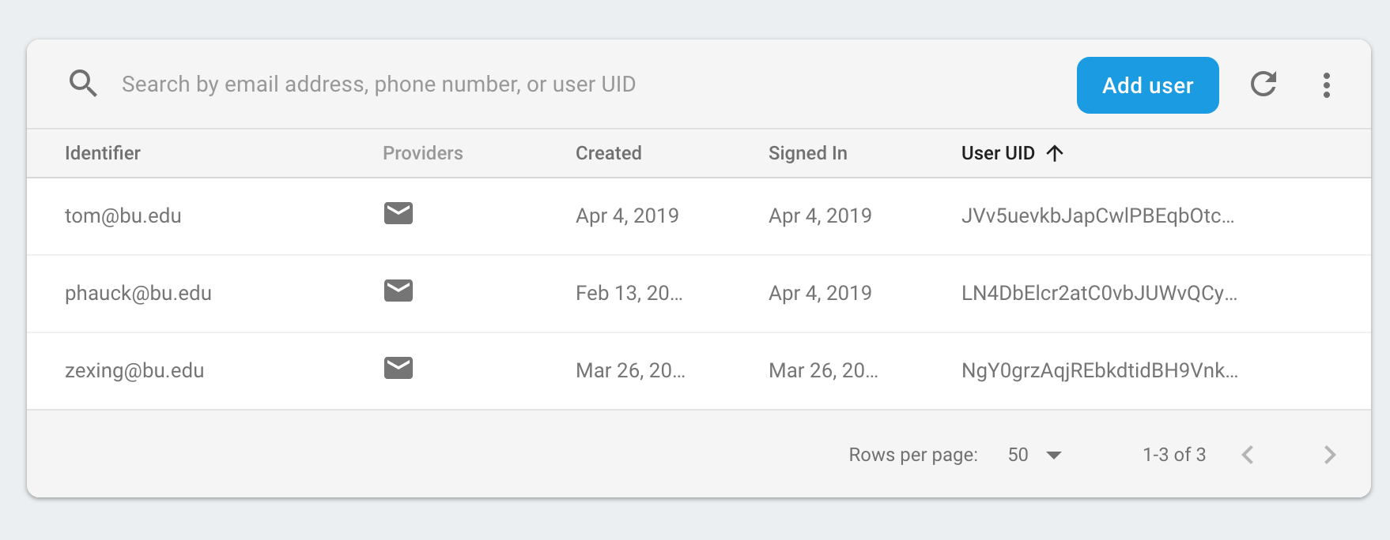

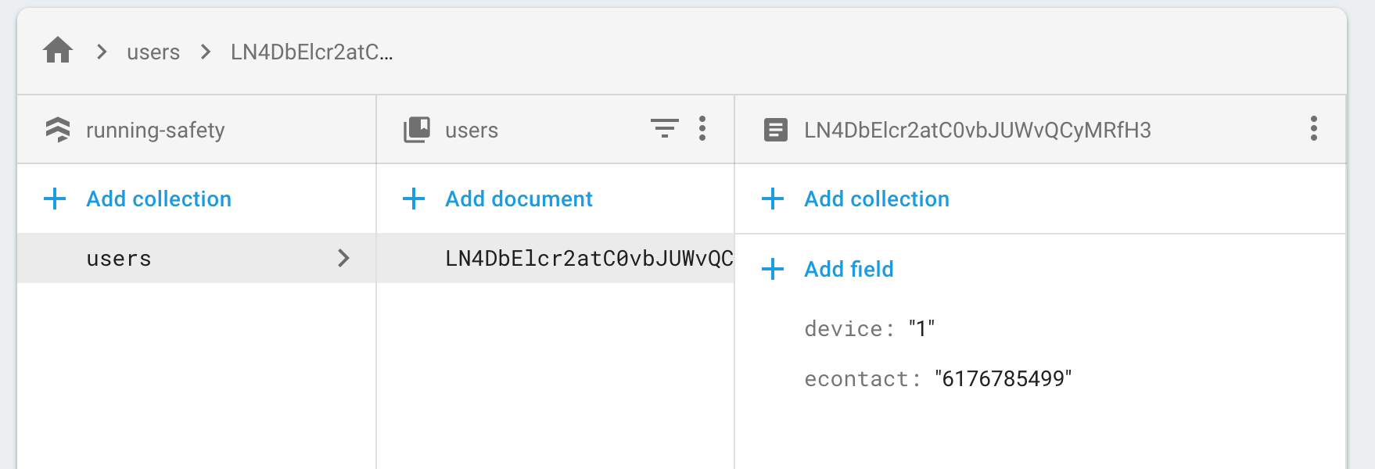

The overall web application was designed and scripted through Javascript and Node js. Node js was the perfect choice for our web app because it made working with the Twilio API and Firebase API easier to implement into the web app. When using Node js, a lot of excess libraries and packages need to be installed, which can be the time consuming part, but once all of those are set communication across the app is easy. Due to being hosted on AWS, outside users luckily do not have to go through the process of downloading all of the libraries and modules that one must have to use our web app. Another benefit of using node js, as far as the Firebase implementation goes, when using the SDK package through Node js, our developing team had “admin access”. This help us set up strong security, and make our own preferences when it came to setting up the web app. If you do not use Node js, sometimes the web app is not as secure as majority of the data and information could be running through the front end.

The styling of our app used CSS to help set up a pre-made styling sheet. By having the styling sheet it was easier to implement all of our functions into the web application in a more formal layout. The layout made it easier to design both a login and sign-up page, then our home page was all based off of how we wanted to lay it out.

Finally, our software was setup on AWS. We create a server which we run our web app on this server. Since the IP address will change every time, so we use the elastic IP address which will not change. Then we associate the elastic IP address with the virtual machine address then link our domain name to this IP address. Our domain name is [www.seniordesignrunningsafety.com:8080/login.html](http://www.seniordesignrunningsafety.com:8080/login.html).

# Cost Breakdown

**Cost of the parts used for Beta Version:**

|  |  |  |
| --- | --- | --- |
| **Item** | **Description** | **Cost** |
| 1 | Pulse Sensor | $25.00 |
| 2 | Vibration Motor | $10.00 |
| 3 | Tactile Button switch (6mm) | $0.05 |
| 4 | Round Force-Sensitive Resistor (FSR) | $14.00 |
| 5 | Beetle BLE (x2) | $39.80 |
| 6 | Adafruit Fona 808 | $49.95 |
| 7 | GPS Antenna | $4.00 |
| 8 | GSM Antenna | $3.00 |
| 9 | SIM Card | $9.00 |
| 10 | Lipo Battery | $8.99 |
| 11 | SIM Card monthly bill (x6) | $60.00 |
| 12 | AWS Fees | $3.00 |
| 13 | Domain name | $12.00 |
| 14 | Boost Converter | $23.98 |
| 15 | CR2032 Holder | $1.95 |
| 16 | CR2032H (x2) | $1.60 |
|  | Total | $266.32 |

Above are the costs of each individual part we have used and expect to use for our “Beta” version as of right now. Obviously, the total price is much higher than what we would prefer, therefore if we began to sell this product to the general public we would need to make manufacturing partnerships to lower our costs in order to sell the product and make profit. The goal would be to sell our product for ~$100, since our competitors are around that price, therefore we would like to drop our costs down to around $75 per each device. I believe this is very possible if manufacturing partnerships would play out. With 65 million runners across the country (and growing), our product has the opportunity to form a billion dollar company. Therefore, eventually our team may say our product and design to a larger security company or running company that may want to invest and make more revenue with our product!

# Appendices

## Appendix A - Specifications

|  |  |
| --- | --- |
| **Specs** | **Details** |
| Power ( In-shoe device) | 6v - 2x 3v CR3032H coin cells |
| Power (For device in chest strap) | 3.7v - Lipo rechargeable battery |
| Chest strap length | Adjustable |
| Case dimension | 12cm x 6cm x 1.5cm |
| Sensors | One force sensor in shoe insert and one pulse sensor along chest strap |
| Database | Firebase cloud stores emergency contact and device number to user’s personal UserID |
| Emergency Test | Includes Google Maps link to the user’s most recent location from when an emergency happen |

## Appendix B – Team Information

**Thomas Cimino** - Electrical Engineering

*Team Role:* My role on the team centered around hardware development of the device. Some crucial design requirements of our device is to not require user input in any way to send the emergency text and to not rely on the user’s smartphone in any way either. With this in mind we had to decide how to make the device autonomous and reliable while also being convenient and easy to use. I was able to implement a design that accomplishes all of these facets and I also assisted in the housing designs led by Yajing.

*Future Plans:* Following graduation I will be working as an electrical engineer for Northrop Grumman at their Baltimore, MD location.

**Zexing Gao** - Computer Engineering

*Team Role:* My role on the team is involved Software Development of our web application. To be specific, I am responsible for constructing the main framework of our web application, design the front-end system, and also integrate all individual modules that finished by my teammates together. I am also the test engineer in the team. I did the test for the entire system to check if there are any issue after the web application is launched on AWS server.

*Future Plans:* Following graduation I will attend to Carnegie Mellon University for graduate study on the field of Information Systems Management.

**Cong Han** - Computer Engineering

*Team Role:* My role on the team is to figuring out how to connect the hardware part with the software part via twilio, and I can grab data from text message and also trace the data from database. Then I apply all software app on the AWS and helped to deal with the problem of web app, such as firebase or css. I also connect our project to a domain name, so that user can use the app online.

*Future Plans:* I will continue my academic study in electric and computer engineering after graduation. I’m waiting for the offer from Columbia University, otherwise I will go to University of Pennsylvania or Duke University.

**Payton Hauck** - Computer Engineering

*Team Role:* My role on the team involved Software Development of our web application. Specifically I was in charge of the login functions through user authentication, then also in charge of setting up the cloud storage for all user data. This involved making sure the data was secured and only accessible by our device and the specified user. For both of these I was able to integrate them through the Google Firebase API. I also assisted Z and Cong in any other development issues we came across.

*Future Plans:* Following graduation I will be working as a Software Developer at John Hancock based in Boston, MA.

**Yajing Lai** - Electrical Engineering

*Team Role:* My role on the team is to do the appearance design and user comfort optimization. Device cases includes both chest part and shoe part. I was in charge of doing the 3-D printing cases by using CAD Software, and machine-cut case by using the tools in EPIC. The final version of our device housing is designed for both comfort and utility.

*Future Plans:* After graduate, I will work in finance industry as a business analyst or investment associate in China.